Hi everyone,

My name is Nikhil, and I’m excited to share that I’ve been selected as one of 100 free hardware recipients for the global Board Designer Competition hosted by Hackster.io. I’m competing with my project, **Sentinel-Fall: Smart Radar & BLE-Based Fall Detection System**, and I’m looking for passionate teammates to join me.

### **Project Overview**

**Sentinel-Fall** is an advanced fall detection system designed for elderly care and industrial safety. It uses a 24GHz radar sensor (MR24FDB1), a PIR sensor, and the nRF54L15 BLE SoC to deliver reliable, contactless fall detection—without relying on cameras. The system also integrates WiFi (EBYTE E34-2G4H) and GSM (SIM800L) modules to send real-time alerts and ensure prompt emergency response. We’re targeting the Kitchen Sink Award, which challenges us to incorporate as many components as possible using the nRF54L15.

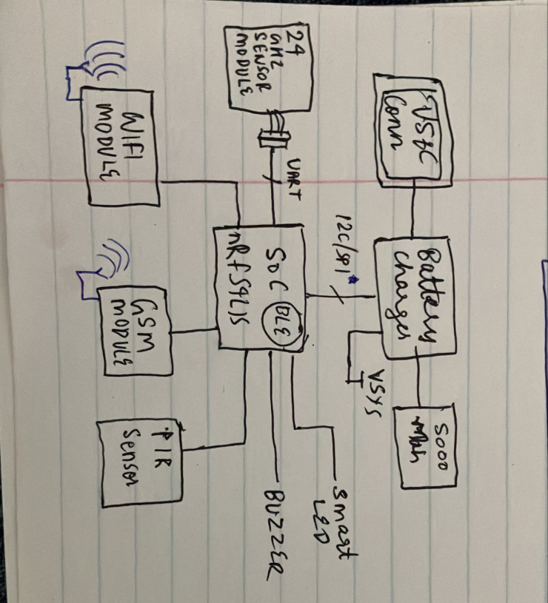

For more details, please check out:

* **Project Idea & Details:** [Hackster.io Project](https://www.hackster.io/nikhilbhatprofessionemail24/sentinel-fall-smart-radar-ble-based-fall-detection-system-265fd4)
* **Project Demonstration Video:** [YouTube (3 min)](https://www.youtube.com/watch?v=R_Ueeu36qMc) *(Note: Our final build will be a PCB-based system with a professional 3D casing.)*
* **Sensor Information:** [GitHub – Seeed Studio MR24FDB1 Sensor](https://github.com/limengdu/Seeed-Studio-MR24FDB1-Sensor)

Additional info on the competition: [Hackster.io Competition Details](https://www.hackster.io/contests/boarddesigner/hardware_applications/?page=1)

### **Team Roles Needed**

* **PCB Designer**
* **2× Embedded Developers**
* **Optional:** 3D Casing & Modeling  
   *(I have family members who can assist with this if needed, otherwise we can use a cardboard prototype.)*

*Note: I will handle the hardware schematic design and overall hardware architecture—feel free to pitch in ideas.*

### **FAQs**

* **Is the project complex?** Not really—the main challenge is interfacing a 24GHz sensor module that outputs via UART. The rest involves programming the wireless modules. PLUS ill be getting a 200$ (16,000 rs +) pcb way gift card to build and assemble the pcb.
* **When is the deadline?** Project submissions are due by May 7, and I expect the populated PCB to be ready by the end of this month.
* **What are the benefits , what's in it for me?** Winning on a renowned platform like Hackster.io can boost your credibility as an engineer—great for Ivy League admissions or standing out at companies like Apple or Qualcomm. The prize is valued at around $1600 (an $800 PCBWay gift card plus an $800 logic analyzer). Even if we don’t win, we’ll have built an impressive, largely sponsor-supported project to showcase.
* **How will we collaborate given that I’m in the USA?** We’ll start with prototyping on development boards (using, for example, the Seeed Studio Xiao for the nRF54L15 along with WiFi, GSM, and PIR modules). Once the PCB is ready, you can SSH into my lab setup for testing. I have access to a state-of-the-art lab and a free 3D printer at my college.
* **What are our chances of winning?** We’re aiming for the Kitchen Sink Award, one of seven award categories. Out of over 250 registrants and 100 free hardware recipients, the top three in each category will be recognized. You do the math!
* **What is the judging criteria?:**Innovation and Originality (20 points)

Technical Excellence (20 points)

Functionality and Performance (20 points)

Aesthetics and Design Presentation (20 points)

Documentation and Presentation (20 points)

Bonus: **Autodesk Fusion** use (40 points)

Since Autodesk Fusion carries such significant weight in the judging criteria, we should use it whenever possible unless it proves absolutely impractical and hard.

* **How many team members?** A maximum of 5 members as per competition.
* **Time Commitment:** We’ll primarily work on weekends, as most team members (including myself) have full-time jobs during the week. I expect each member to contribute about 5–6 hours on Saturdays and Sundays. Specific roles and contributions will be discussed based on your expertise.

**If you’re serious about contributing to this exciting project, please let me know within the next two days. I’m reaching out to several contacts, and our team is limited to 5 members as per competition.**